EPHESIANS 6:10-18.

Every day we must put on the armor of God anew.
This prayer will certainly help you to do so.

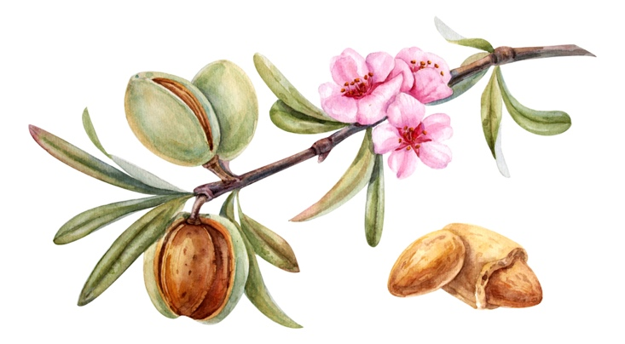

ARMOUR OF GOD

Heavenly Father, your warrior prepares for battle, Today, I claim victory over the enemy Satan by putting on the whole armor of God. I put on the GIRDLE OF TRUTH May I stand firm in the truth of Your Word so I will not be a victim of the enemy's lies. I put on the BREASTPLATE OF RIGHTEOUSNESS May it guard my heart from evil so I will remain pure and Holy, protected under the blood of Jesus Christ. I put on the SHOES OF PEACE May I stand firm in the Good News of the Gospel so Your peace will shine through me and be a light to all I encounter. I take the SHIELD OF FAITH May I be ready for the enemy's fiery darts of doubt, denial and deceit so I will not be vulnerable to spiritual defeat. I put on the HELMET OF SALVATION May I keep my mind focused on You so the enemy will not have a stronghold on my thoughts. I take the SW*O*RD OF THE SPIRIT May the two-edged sword of Your Word be ready in my hands so I can expose the tempting words of the enemy. I take the heavy artillery W*E*A*PON OF PRAYER May I keep praying without ceasing, so that I am not deceived. By faith Your warrior has put on the whole Amour of God and am prepared to live this day in spiritual victory. In the Holy & Mighty Name of Jesus Christ of Nazareth, Amen

