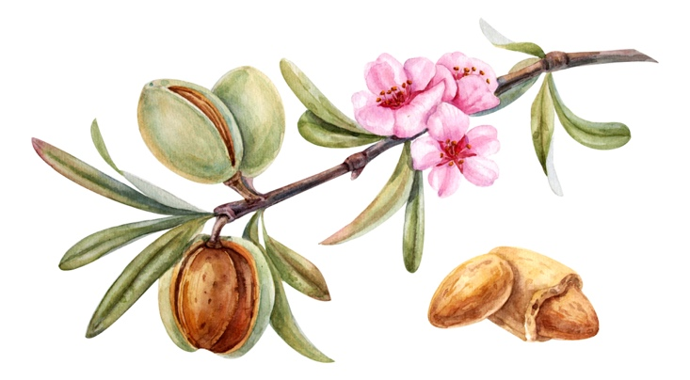

**And as it was in the days of Noah, so shall it be in the days of the Son of man.**

**Lukas 17:26:30 Genesis 6 in 7. Mattheus 24:38-39.**

**The Lord Jesus prophesied of the time we would live in when he returns. He foretold the circumstances in which we would live. We are very advanced in time. The wars and the rumors of them are not the end but the beginning, the beginning of the woes. Revelation 5 through 11. 9 and twelve.**

*The Bible is God's word, a guide to eternal life. It is the truth of God, and we must not detract from it or add to it, it is a lamp at our feet in a dark world. It is written to help us understand who God is, His character, and what He requires of us in order to enter into eternal life. And what He can and will do for us if we choose Him and live for Him.*

In ancient times, just before the flood, man was offered a refuge in the ark to escape the judgments of God. Noah prophesied for 120 years about the coming of judgments, and no one believed him or wanted to believe him. It was a terrible time in God's eyes. God regretted that He had created man, it was so bad*. Genesis 6.* In the end, eight people were allowed in the ark. Only Noah was righteous in the eyes of God. The other seven persons (his family) were admitted by grace. The flood came *(Genesis 7)* and then the world was rebuilt and repopulated. The time of Noah was the time of the fallen angels, the nephilim and the giants, the earth was full of violence. Genesis 6:11. The giants who lived at that time and, as is written, also in the time after, which means after the flood. *In those days and also afterwards there were giants on earth. Violent people from old times. Genesis 6:4.* Evidence of this has been found all over the earth. And we see violence increasing in our days and this will continue to increase. People are going to change and we are going to see things we have never seen before. If you are familiar with Greek mythology and the creatures described in it, you will get a bit of an idea of what is to come. For many these are fairy tales or folklore, but it is in fact an eyewitness account of what orphans have walked around on earth. For example, in the Bible book of Jop there is mention of Leviathan, Job 40 a huge sea creature created by God who cannot be defeated by anyone, it all comes back.

The communion of angels (the watchmen) with women and the other mutations that arose, such as half man half animal, were and are all against the will of our Father. Nowadays it is possible to clone animals and fabricate "parts" from animal tissue for humans. This goes against creation and the creator Himself and is a repetition of the days of old. You will find much more information about how it was and how the weather will be. in the book of Enoch. You can download this book on my website.

Through the choice that Adam and Evan made, sin has been brought into paradise, with which satan has been granted permission to rule over the world. And the earth is under the curse. The curse that is broken when you turn to the Lord Jesus. From the foregoing you can clearly see what consequences sin can have in the life of a person. You can't foresee the consequences in advance. What happened in the days of Noah comes back as the prophecy of the Lord Jesus states.

*In our days we have the Lord Jesus as an ark and many people have more opportunity than in those days to be allowed into the Kingdom of Heaven.*

In our time it is no different than in that time, the time before the flood, there is a lot of sin, such as genetic manipulation, transhumanism, gender confusion and all kinds of other deviations from the teachings of Christ. There are similarities to the time of Sodom and Gomorrah with regard to sexuality in the days of Lot. Study Lot's story for yourself. At the Second Coming, it will be the same as in those days on earth. Luke 17:30. We can learn from Lot that we should not look back at our lives when God calls us or when we choose Jesus. We let go of our old habits and are renewed by His Spirit. We can't live the old way. If we look back like Lot did, the same thing happens to us, we lose everything, our current life including our soul. If we follow Christ, we will live and the loss of the things of our old life is gain. *Luke 17:33*. *Whoever will try to keep his life will lose it, and whoever will lose it will save it.*

Many think that the Bible consists of 66 books. This is not an accurate representation of what the Bible itself says about the books that are not (or no longer) in it, books that we do not find in the Bible are mentioned as such in various places.

**The books are not included.**

Below are two examples of Bible books that are mentioned by the apostle Paul but are not included in the Bible itself. The fact that these books were not written down by compilers of the Bible says nothing about the validity or authority of these books. Fortunately, they have been preserved, so we can investigate for ourselves what the time before the flood looked like and what we can expect in return.

Many think that the Bible consists of 66 books. This is not an accurate representation of what the Bible itself says about the books that are not (or no longer) in it, books that we do not find in the Bible are mentioned as such in various places. The apostle Paul, among others, also speaks about the books: They are of great importance for us to better understand the end times, for example.

The most famous book is the book of **Enoch**. This book is an important book because it describes what happened in the time before the Flood and the reasons for the Flood.

Jasher

The book Jasher can only be downloaded in English. It is mentioned in the Bible in Joshua 10:13. And in 2 Samuel 1:18. It is also called the book of the Righteous.  The book of Yashar was even read by Columbus and used in his preparations before he left for America. Because in this book, Jasher, mention is made of the expelled or lost tribes of Israel and some of which ended up in the Americas.

And so the truth comes to light more and more and we understand more and more of God's plan of salvation and the prophecies about the true Israel, all the house of Israel, in this time, for example in the books of Jeremiah and Isaiah. Many Bible texts become clearer in this way and are a wake-up call for us.

**The book of the Giants.**

There is a book in circulation, **The Book of Giants**, which also explains what the time of Noah entailed. The Nephilim, the giants and the mermaids, for example.

Jesus did much more.

The Lord Jesus has done much more than is written in our Bible, too much to write down. You can read it in John.

*Johannes. 21:25.*

*And there are many other things that Jesus did. If each of them were described separately, I don't think the world itself could contain the written books. Amen*

***13 January 2025.***

***A short update on the time and expected events.***

*The nephilim will appear soon, as will the fallen angels. These beings are very powerful beings, they are already present in the mind. And the advertisements with aliens can already be seen frequently to "prepare" us and drones appear above American cities, it is a matter of time before we start observing them. Stay away from it, it is pure darkness. (Read the article about the fallen angels in Revelation 12.)*

*Only if you remain in the protection of the Lord Jesus are you safe. Then work your relationship with Him. He alone can protect you, don't rely on your own judgment. Involve Him in everything you do and your relationship will grow.*

*Protect yourself every day by asking for the blood of Jesus for protection. Jesus is alive and His blood still has the same power as it did on Calvary.*

*Listen to the Holy Spirit when you go out, for example, always ask for protection for your house, your car, etc., the journey itself and your homecoming. If you are on the road and you get a feeling not to go somewhere or to leave, do this, listen to this. It is the Holy Spirit who guides you. It's for your own safety.*

*Make your way straight with the Lord Jesus. Keep praying and be obedient, giving thanks and praising Him. Worship Him in truth and in the Spirit. John 4:24.*

*And rejoice in the Spirit, and always look up and seek the things that Are there. The affairs of the Kingdom of Heaven.*

*Organize prayer groups to strengthen each other with God's word and prayer. Study the four Gospels to get to know the Lord Jesus better and what He requires of us. Living with Christ is described in many books of the Bible, but Romans 8 is very clear about living in the Spirit. Also remember that your own relationship is the most important thing and you only build it by communicating directly with Him, through prayer and reading His word.*

*Now, when these things begin to happen, look up and lift up your head, because redemption is at hand. Luke 21:28.*

*I wish you many blessings and pray to the Holy Spirit for greater clarity and revelation of Scripture.*

*Amen*