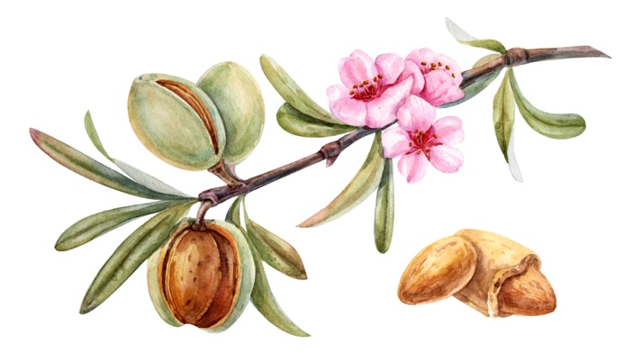

God with us
In Isaiah 7:14. and Isaiah 8:3 the prophecy about the coming of the Lord Jesus is recorded and God makes clear who He, the Lord Jesus, really is. "Behold, the virgin will conceive. She will give birth to a Son and call His name Emanuel. Emanuel means God with us.
There are plenty of scriptures that indicate that the Lord Jesus is God Himself who came to earth to tell us of His grace. Out of love for us, because it is not possible to live a holy life on our own and thus save our souls. The word became flesh and dwelt among us John 1:14. Everything originated from the word John 1:3.
Also in Isaiah 53:9 it is prophesied about the coming of the Lord Jesus. In Matthew 1:23. Is this prophecy quoted and has it been fulfilled? But He was wounded for our transgressions and bruised for our iniquities. The punishment that brings us peace was upon Him, and through His stripes we were healed.
In Isaiah 9:6 we read who He really is.
For unto us a child is born, a son is given to us, and the dominion is upon His shoulder, and His name is called: Wonderful Counselor, Mighty God, Everlasting Father, and Prince of Peace.
God created all things through the Lord Jesus, His dominion, that is, all power and authority over all creation is in and through Jesus Christ now and forever. Don't know? Didn't you hear? The eternal God, the Lord, the creator of the ends of the earth, does not grow weary and weary. Isaiah 40:28. God has made Jesus heir of everything, through whom we also made the world. And as it is written; For in Him we live, move, and exist, just as some of your poets have said, For we are also of His race. Acts 17:27:28 And is always near. In Romans 1:20 we read about the eternal power and divinity of the Lord Jesus.
He is the truth, John 14:6. and without Him we do not come to the Father. If we know the Lord Jesus, then we also know the Father. We know the Lord Jesus submarine by His word.
He has sent His Spirit to help and comfort us, and to intercede for us by praying to the Father for us. John 14:16. Christ in us.

Proverbs 30:34
Who ascended to heaven and descended from there? Who has gathered the wind in His hands? Who has tied the waters in a garment? Who has determined all the ends of the earth? How is His name and the name of His Son?

God confirms His love for us by the fact that while we were still sinners, Christ died for us. We are reconciled to Him through the death of His Son and saved by His life. Romans 5.

"I and the Father are one".
John 10:30.

www.onzegezegendehoop.nl


