

Three days of darkness.
Exodus 10:22. Update September 2024.
The three days of darkness and the other plagues that precede the return of the Lord Jesus will come upon the whole world. We are living in the time of judgment for the return of the Lord Jesus. This time is characterized by God's judgments on nations, persons, and institutions. This is a result of forsaking God and His commandments and living in sin or approving or enabling and thus participating in it.

Introduction
The judgments go hand in hand with the increasing withdrawal of God's presence here on earth and over our lives. It is the hand of God, for example, that stops evil in its worst form and his hand that keeps everything in a reasonable balance. Or rather, stayed, because this is changing. Mankind has in many places pushed God away from society or daily life. It is prophesied, the grace of God will be taken away, and then the world will live in darkness. The Holy Spirit remains present, in people, of course, and as a protector for those who have the Holy Spirit. Receive.
A world without God becomes a world without boundaries and commandments that are there to protect us from ourselves. We see more and more "proof" of this in our society and in religions.
The coming (it's already here, The Great Reset) of the beast system, Daniel 7:23-24, to which the 10 kings of the earth give their power, will be a ruthless world led by ia. Super efficient and will shut out anyone with little use to society. People big and small will have to meet a set standard. If that standard is not met, you are not good enough. Too fat, too thin, too few steps made in a day, too few social media likes, etc.
It will be different from all the kingdoms before because it will now devour the whole earth, this is the technology, the algorithms that are going to determine your "value" to society. It is the instrument of the antichrist system, the beast system. And if God would not intervene, there would be no flesh (man) left, so heartless would our world becomes. And it's already happening before our eyes.
Matthew 26:41. And if those days were not shortened, no flesh would be saved; but for her elect's sake, those days will be shortened. The chosen ones are the people who have chosen Jesus or are going to do so. God does not exclude anyone, the responsibility for salvation lies with each person.
Whoever wants to save his life will lose it, but whoever loses his life for Me will find it. Mathew:24-28. This is about denying yourself and giving your life to Jesus every day so that we will live forever, even if we lose our present earthly life for whatever circumstance or reason.
The End Times
For many centuries it has been warned by the prophets and what is written in his word.
God has announced it in Revelations, Jeremiah, and Isaiah, and many other messengers that has gone around the world. Also, in our time.
There is hope for Christians who are born again of eternal life and protection by the Holy Ghost, the only shield against all this is the Lord Jesus. Isaiah 4:5 speaks of the protection afforded to the righteous during the turbulence, as it was in Exodus 13:21-22 while the Israelites were protected by the Lord during their exodus. He will protect and guide us, now through the Holy Spirit.
It doesn't mean that things will get easier in the coming years, or that unpleasant things won't happen in your life. What is 99 percent certain is that you, your soul, will be saved. That one percent is the possibility that you still have hidden sins or still leave the path of Christ and embrace the Beast system in which we are slipping further and further away and, for example, take or fall the mark for the lies of false doctrine. Revelation 13 and 16. We will have to persevere in faith, stand firm, and fight for the truth.
Anything that is not acceptable to God cannot be taken to Heaven. That is a fact, and nothing can be condoned. Revelation 21:8. Therefore, it is necessary that you ask forgiveness of your sins every day so that they can be forgiven and that you live a holy life. Confess hidden sins to the Lord Jesus and ask Him to deliver you and forgive you. That's the biblical way. We are sinners and, although saved, we are no longer slaves to sin because the spiritual takes over in our lives through the influence of God. However, if we do sin again, the Lord Jesus is willing to forgive us again.
God is going to shake the world.
The world will be shaken by natural disasters on a large scale, by plagues such as those described in Exodus and in Revelation.
Allowing deceptive events that are difficult to distinguish from the real thing. Like the coming of the fallen angels. I can only bless this: be on your guard, listen to the Holy Spirit, for He is the only one who can discern these things so that you do not fall for the temptations.
We must not be naïve and call everything good and love, because it certainly is not. There are "friends" from so-called other worlds, helping us during the crisis. These are not out for friendship but for your downfall. As soon as there is more talk about this in the media, it is time to keep your distance from it, always! Proclaim Psalm 91 verse 7 about your life and home.
It will be a very difficult time and difficult not to fall for the temptations. And this is largely the result of the abandonment of God's truth, rebellion against God, and the sins of the past committed by nations, for example, that are yet to be judged. Or we as humanity must proceed en masse to conversion.

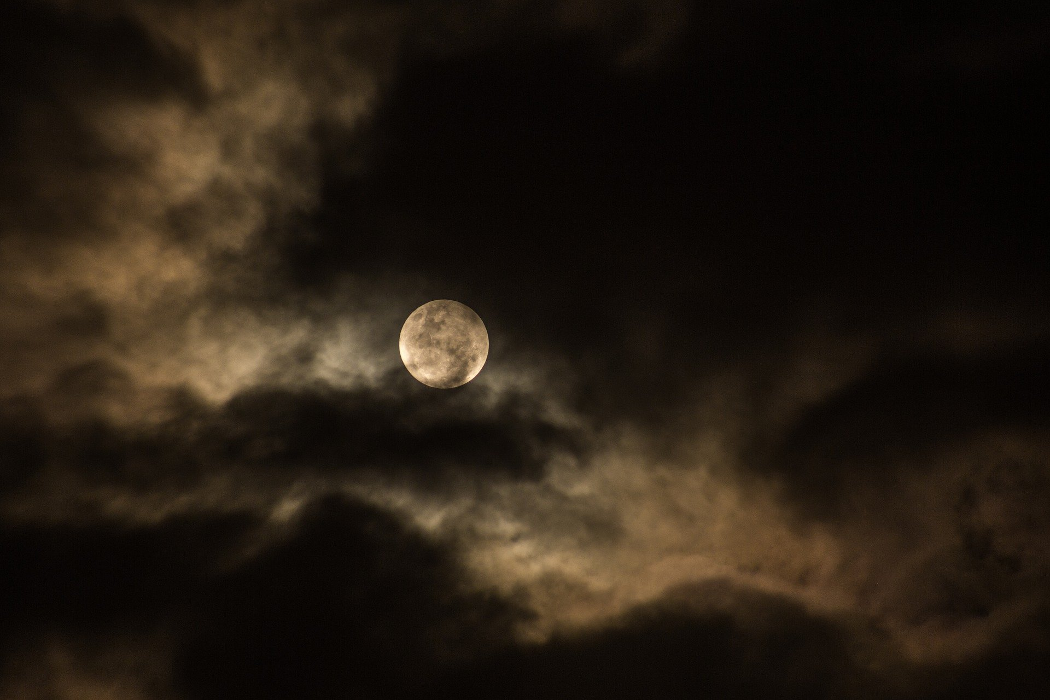
About the three days of darkness and the plagues to come.
The period that has come is called the hour of temptation that will come upon all the earth to tempt those who dwell on the earth. Revelation 3:10.
The three days of darkness is one of the judgments due to the worship of other gods and sinning against the will of God which is widely practiced, also by Christians, An example is for example celebrating Halloween or making stone statues of, for example, forest creatures, clergy etc.
Because God is a jealous God, He has commanded that no other gods be worshipped or imaged. And more generally, about rejecting God as our Lord and His Son as savior, the plagues of ancient Egypt are also coming back upon the earth.
"Thou shalt not make for yourselves an image, not a single image of what is above in heaven, or below on earth, or in the water under the earth."
This also applies to all of these revelations 13 and 16. Christians cannot and must not bow down to other gods or images thereof. Which amounts to all the religious expressions that you place between The Lord Jesus and yourself.
Other idols, which are more important to you than the Lord Jesus, are also included. This can be anything that we let ourselves be controlled by in daily life. Therefore, make the Lord Jesus the most important thing in your life. The one you spend the most time with and whose commandments we observe.
The Lord Jesus did not start a religion, nor did Paul and Moses. It is the man who has added and thought of all kinds of things about the Gospel.
Nowhere in the Bible do you find that it is okay or necessary to perform rituals or perform other works in the field of religion. All of this started with the merging of a number of Christian sects and the Roman idol culture. Working as charity, caring for one another and bearing each other's burdens are not religious works, being is a sign of love, the love of Christ and expressions of the Holy Spirit.
The Romans had gods (demons) for everything with temples attached to them. Like the Pope, they were worshippers of the sun and the moon. etc. It is mixed with Christian texts and thought and thus made into a religion.
The plagues from exodus.
The first plague will be that the water will be turned into blood all over the world. The sea, rivers and the water that comes out of our tap. Revelation 8:7-8. There will be new diseases and new measures.
You will find all the plagues in Exodus 7 to 14.
Exodus 20:4-5.
Bible places where the three days are mentioned.
First of all, I should note that there is a pattern in events related to the end times and the return of the Lord Jesus, a pattern of three days, hours, etc. For example, Jesus appeared three times after his crucifixion and resurrection, to different people. It was dark for three hours after the crucifixion, and there are many more scriptures to discover where this three-day pattern is described. The sufferings of the Lord Jesus are also announced three times, Mark 8, 9 and 10.
Exodus 10:22.
The comparison with Egypt certainly applies to our time. God brought his people out of Egypt at that time, so the Old Testament is a foresight of the things that will come at the end. And now Jesus is bringing us home. He is the ark, and our body is the temple in which the Holy Spirit dwells, the tabernacle. He gathers everyone from all corners of the world and brings us home to spiritual Israel. (See also "The Miracle of Repentance" and God's Plan of Salvation.)
The expulsion from Egypt was a preview of the exodus of believers now, who also live in "Egypt" given the many idolatries of our time slaves to sin. And it is now, in our day, a warning to give this up and renounce the occult and the rejection of the Son of man.
Amos 8:9 in Amos 5:18. Johannes 9:8Joel 2:11 in 3:15. Isaiah 13:9-10 Openbaringen 6:12-14. Lukas 21.
Acts 2:20.
This is not just about the darkness, Jesus' answer to the scribes and Pharisees about the sign of his return:
The only sign for his arrival.
As I have written before, there is only one sign that Jesus gives for his coming, namely what is described in Matthew 12:40. "For as Jonah was three days and three nights in the belly of the great fish, so shall the Son of Man be three days and three nights in the heart of the earth." And in Luke 11:29 the sign of Jonah. Those are the three days of darkness that Jesus refers to. It is a pattern that will also repeat itself. And the three days are a sign that we are very close.
This has to do with the fact that the Lord Jesus Himself was in darkness for three days, namely hell, immediately after the crucifixion. To preach there to the people who were imprisoned there. A second chance, mercy, for people who had died in the time of Noah and had come through the flood because they were disobedient. Only eight people were rescued at the time. Can you imagine how many souls have been saved for eternity after the Lord Jesus has preached the Gospel in the darkness to these people? Just like it is happening now, against the current, worldwide.
1 Peter 3:19-20.
By whomever He preached to the spirits in prison (hell) when He departed.
After the crucifixion it was also very dark, for three hours and there was a big earthquake. Unfortunately, we also must experience this darkness for three days in order to experience what He has experienced, because followers of the Lord Jesus also share in the sufferings of Christ.
"But rejoice according to the extent to which you are partakers of the sufferings of Christ, that you may also rejoice and rejoice in the revelation of his glory. If you are reproached for the name of Christ, then you are blessed, for the Spirit of glory and of God is upon you. 1 Peter 4:14
Even now, just like in Noah's time, there are many people who do not believe that we are living in the end times, that plagues are coming, or that Jesus is coming back and that there is something like a rapture of those who choose him and hold out until his return to be saved.
The Bible is full of them, you must learn to see these patterns and investigate them for yourself, then it is amazing to discover what plan God has written down for the salvation of mankind. Everything is aimed at reconciling you to Him. It is an offer of grace and love.
Revelation 3:12:13. It concerns your relationship with the Most High, the Son of Man. It is not the time to get your oil from someone else, but to get ready for the Wedding with the Lamb (the Lord Jesus) Revelation 19:6-10. Matthew 25:1-13. So that the door doesn't close for you.
This occasion is the event spoken of in Matthew 24:29, Luke 17, and Revelation 6:12. These three Scriptures tell of the same event.
It is the day of the wrath of the Lord Revelation 6:17 "For the great day of his wrath has come, and who can stand?"
What will happen those days?
Before it gets dark for three days, there will be a catastrophic event, and then there will be a massive earthquake that precedes the three days and will be felt all over the earth. This, too, is a repetition of the events surrounding the crucifixion and resurrection of the Lord Jesus.
It will be very dark, the whole earth will be through a thick blanket of darkness that you can even feel. For three days and three nights this will be so. You must stay indoors. The electricity will be out, but also the internet etc. It is a repetition of Exodus 10:22. The ninth plague. Due to the eclipse of the sun and the moon, the temperature on earth will drop, it will be very cold. If you want to be safe during this time you should not go outside these days, you will not survive, close the curtains and stay away from the windows, especially do not open the door for anyone.
Why not go outside or open the door.
These days there is already a demonic power ruling over the earth that will try to take souls away from the utter darkness. This power will go from house to house. People who live in sin will be noticed and taken away because an opening has been created by these sins in the safe shield of the Holy Spirit. That's the best way to describe it.

God warns us in Isaiah about this time of darkness.
Go, my people, enter your chambers, shut your doors behind you. Hide yourselves for a little moment, Until the wrath is over. Isaiah 26:20.
Ezekiel 9 speaks of sealing with the Holy Spirit. It is a preview for us currently. However, we no longer must put blood on the doorpost but are now protected by the blood and the Holy Spirit.
Even if you are in a house where there is a lot of prayer around that time and there are many Christians in that house, they may be at risk if there are also people in their midst whose sins are not forgiven or who are trying to hide sins from God. However, this is impossible: God sees and knows everything. So do the demonic powers and therefore have a right to enter that house.
And there is no creature invisible to Him, but everything lies naked and bared before the eyes of Him to whom we are accountable. Hebrews 4:12
Not opening the door because there may be someone at the door pretending to be a deceased family member or someone you were at odds with, the demonic powers can imitate anything. If you accept this, you are lost. The best thing to do is not react at all and pray instead. And use your spiritual armor, like Psalms, and stand in the authority of Jesus.
So stay away from that and pray that you may be protected. Don't argue. And pray for help and protection from the Lord Jesus. For example, remember Psalms 91, 27 etc.
A person who has died never comes back, is no longer with us or in another place so that we can observe them. It is demonic when such phenomena occur. Departed people are in a prepared place and sleep until the day of resurrection. Hebrews 9:27. And as it is ordained for men, they must die once, and then judgment follows. This means that there are no "dead" people in our sphere, they are somewhere else to appear before God later. It is demonic if you think that contact with loved ones would be possible or that you still feel them in the house, etc. The enemy plays on our emotions. This also occurs in dreams, reject it and send it away in the name of the Lord Jesus Christ.
You can't open the door, even if there's someone you know at the door. Remember that there cannot be people outside in this darkness because this is impossible due to the thickness of the darkness, you literally cannot see a hand in front of your eyes, no one is safe outside.
Seal and prayer.
People who have the seal of the Holy Ghost and have accepted Jesus will not have much to fear, no matter what happens outside, they are protected by the blood of the Lord Jesus. By the way, this is something that you have to ask for yourself in prayer, this covering.
Revelation 9:4.
An example
"Lord, I ask you to cover myself and my house with your blood, cover me and my house and that of my friends and children with your blood so that we may be safe from the attacks of the enemy," Amen.
Or:
"Lord, I thank you for the protection of your blood against the terror of the enemy. I ask you to cover my body and house in this hour as well, so that we may take shelter with you safely for this moment or the times to come." Amen
Also read Psalm 91, a good practice every day today.
In their house there will be light. This was also the case in the time of Moses. Exodus 10:23. For all the Israelites, there was light in their homes. Revelation 9:4 and Ezekiel 9.
In ancient times, one had to put the blood of a lamb over the doorpost to protect against the plagues. Now the Lord Jesus is our protection. The last Passover, which literally means to be skipped, we are passed over by the plagues just like then. You can't claim it if you haven't repented and receive the spiritual blessings that come with it. God also warned at the time, and it does today. Examine yourself, and if necessary, make everything right with the Lord Jesus.
It is described in Isaiah 60, about the light in the darkness, the Lord Jesus, and the coming darkness that comes upon all the earth.
Arise, be enlightened! For thy light is coming And the glory of the Lord is passing upon therefore behold, darkness shall cover the earth And dark clouds shall be upon the nations But upon thee shall rise the Lord, and his glory shall be seen upon thee. And the nations will go to your light, and kings to the brightness of your day.
*********
People who have the Holy Ghost will be a light to others in those days. There are many more Scriptures about darkness, but I will leave it at that because the fact is sufficient to pass on to you so that it does not come unexpectedly.
The Vision
I saw the first vision about the three days around the outbreak of the virus that caused everyone to be at home, so I thought it was this event and didn't pay much attention to it. The second vision was sometime in September 2021.
I have seen the darkness twice in a vision and it has been made clear to me in a dream to share this so that it will not overtake you And I am obedient to God. The darkness rolled over the city like a blanket and at that moment I couldn't quite bring it home. The second time was about two months later, again the same image and then the dream. For me, the dream was the confirmation that what I have seen are the three days. And, of course, prayer and the Scriptures.
We need to realize that God is a God of repetition, and what was will repeat itself. So are the days of Lot and Noah, this is also a pattern. He is the Alpha and Omega, the beginning and the end. So it will be again in the times of Genesis and Exodus. The reasons why God is going to shake everything again are the same, only now there is a way out, namely the Lord Jesus and our rapture and forgiveness of sins freely. And it's the last time, because we're in the last days of the last days.
Isaiah 43:9
The foregoing things, behold, they have come, new things I proclaim; Before they germinate, I'll let you hear them.
As I have already written on another page, the Second Coming is to be expected after these days. This will be a terrible day as can be read in Matthew 17:29:37, Acts 2:16 and beyond.
There will be miracles in Heaven... Read it for yourself. It is also written about the awesome day of the Lord. You can also read about this in Revelation 6, the sixth bowl. This is a global catastrophe. But also a time when the Lord Jesus will appear to everyone in all His glory.
In those days when you can't see anything, Jesus is the only light in the world. Then go to him and ask for his protection. I can only conclude that the time before the return of the Lord Jesus will be a very difficult time. Only then comes the Second Coming. Revelation 6:6 tells us a little more about what lies ahead.
The event of the darkness coming upon the earth relates to the coming of Satan to the earth and the opening of the pit in Revelation 9 and Revelation 12. The dragon that casts one-third of the fallen angels to the earth (stars). The dragon is a symbol for Satan, He will wage war against the believers. (Persecution). Satan disguises himself as the antichrist. He's going to rise in America, he's a man everybody already knows. And therefore, will be welcomed with open arms.
Luke 21.
About the events before the Second Coming.
This is a key place regarding all events. There is so much to say about this that I am going to write a separate article about it.
Around the time of the three days of darkness there will be strange signs in the Heavens. One of them catches the eye the most and that is the appearance of beautiful red skies or the Northern Lights in places where they do not otherwise occur. It heralds the three days and also the coming of the fallen angels who are going to mix with humanity and seek its destruction. As mentioned, the fallen angels come to earth with Satan. They come as friends, saviors and handsome appearances. They will also present themselves as masters of light or any function of any kind. For example, they are welcomed by people who expect them from the new age world etc. Contact with these beings or interference in your life has catastrophic consequences. They are not out to help but to destroy your life but also your soul. Workers of evil, Jesus Christ is our shield currently, the run-up to all of this. The antichrist will come into the picture according to the operation of Satan, namely with false miracles and signs. So do not be deceived in this time and the one that lies ahead. For, as in 2 Thessalonians 2:9, the lawless one comes to power according to all kinds of deceptions. "Him who’s coming is according to the workings of Satan, with all kinds of power, signs and wonders of lies." There's something else you could lamb a little further on, which is
2 Thessalonians 2:10-11 and with all kinds of deception of iniquity in those who are perishing, because they have not received the love of the truth to be saved. And therefore, God will send them a powerful error, so that they will believe the lie. That they may be condemned all those who have not believed the truth but have taken delight in iniquity.
We keep in mind that this time also brings the return of Jesus closer. And with it, the resurrection of those who have fallen asleep, and those who endure to the end and who are said to be saved. These people will be changed first: 1 Corinthians 15:51. To be changed is to get your glorified body in order to be taken up by the Lord Jesus. This also happens to the people who have gone before us. They precede us. They rise from sleep, like Lazarus, and go to meet the Lord. After a while, the changed people who are still alive also go.
Ezekiel 37:12:13> "Therefore, prophesy and say unto them, thus saith the Lord, Behold, I will open thy graves, and will bring up to three men out of thy graves, O my people! And I will bring you into the land of Israel. And you will know that I am the Lord, when I have opened your graves, and when I have brought you up from your graves, O my people!
Isaiah 26:19 also describes the resurrection of the dead, the dead body (of Christ), meaning everyone who died in Christ.
Bringing into the land of Israel in this text, the prophecy for end-time events, means that we are taken up into spiritual Israel, the body of Christ. And will reign with Him forever on earth. There is something written about the transfiguration in Matthew 17.
You can read more about the recording in the recording series. These can be downloaded from the website.
Hope for the future.
Because of all the events that are just around the corner, one thing is clear and that is that the Second Coming is getting closer and closer and with it the deliverance from this world. This will not be easy, or without difficulty. Because of persecution, we may not survive. We certainly don't die, but we live on.
Keep your attention fixed on the Lord Jesus, take refuge in Him. You have chosen or are going to choose for eternity, so we can look forward to what God has prepared for us.
Therefore, take the gift of reconciliation and forgiveness today. Confess your sins to the Lord Jesus. Is this a long time ago? Then do it again, for we sin every day.
Summary
From a spiritual standpoint, we are heading for the three days of darkness and the coming of the fallen angels.
Everything that precedes it on earth is a sign that the antichrist will appear. He is building his kingdom on earth. Many are deceived and go along with this. The antichrist is a system, not just a man, he gets help from many. For the spirit of the antichrist is already wandering about the earth after the ascent of the Lord Jesus.
For the antichrist is a spirit, and there are many antichrists in the world. John warned against it.
Our own Bible study and prayer, as well as the help of the Holy Spirit, are indispensable in order not to fall for the temptations or deceptions that are already being poured out on us.
We are getting closer and closer to these revelations. Recently (August 2023) I was reminded of Exodus 10 and the letting go of the people of God as it happened at the time. This call is intended for people who teach a doctrine that differs from what is written in the Bible.
The Update
I wrote this article about 3.5 years ago and since then there have been other revelations about the end times events that I have written down and published. For example, in the article Raise the banner. In the meantime, a few warnings have been made known to me about the things to come and the four horsemen from Revelation 6 are going over the world.
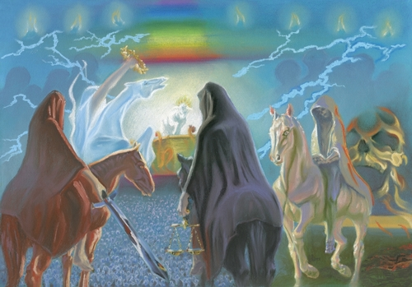
While I am making this update September 7, 2024, I have now received another warning. This warning is found in Isaiah 7. About the birth of the church of Christ, and the coming war. A war that will take place physically over the world, Babylon, through the spread of Christian occultism and the gospel of greed. A spiritual war against humanity in general by the powers and forces of darkness.

It is God's will that no one should perish, and therefore prophecy is a blessing.

Peace, I wish you, and blessing from our Lord and Savior
The Lord Jezus Christ.

